JHARGRAM DISTRICT MEETING

Date: 13.02.2021
Time: 11 AM - 3PM

Reporting By :- Jharna Acharyya
Edited By: Venkatesh Kodukula

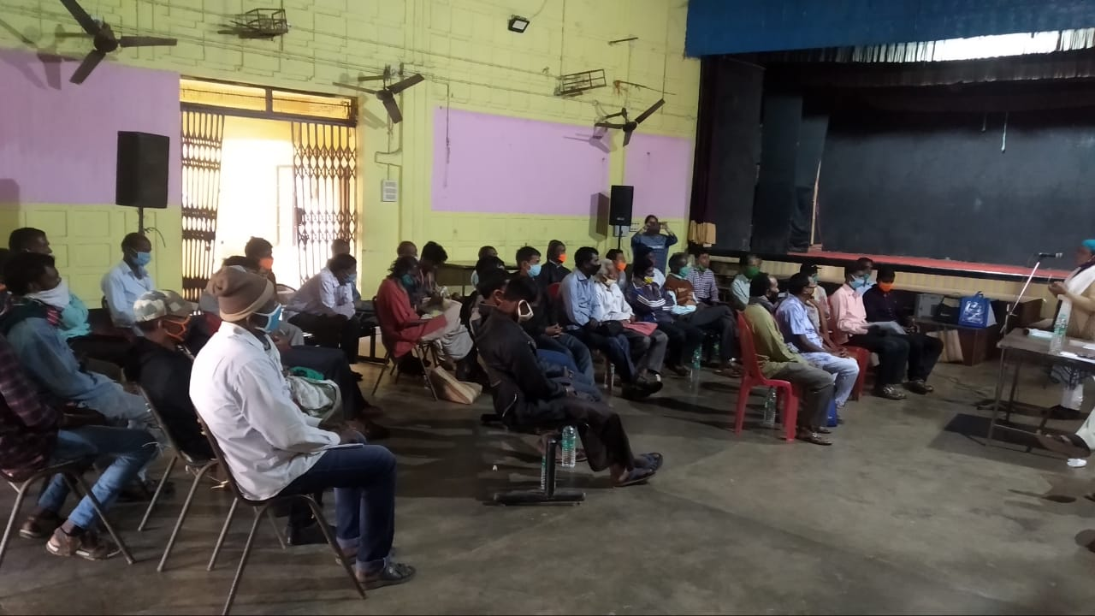

Forest Right Act 2006, Right to Property, Land related issues and Discussion on Violence against Women

Schedule for Meeting
Time | Session | Speaker
11:00- 11:05 | Introduction of HRLN | Jharna Acharyya , Activist of HRLN
11:05-11:20 | Violence against women | Aindreela Dey (Advocate of HRLN)
11:45-12:15 | Forest Rights Act 2006 | Indrajeet Dey, Soumitra Karmakar Chakraborty,Sourat Nandy(Advocates of HRLN)
12:15pm-12:45 | Right to Property and other land related issues | Malay Bardhan , (Advocate )
12:45pm-13:15 | Discussion with victims | Dillip Pramanik Sourat Nandi , Raju Pramanik , Gopal Mallik, Bablu Bhakta
13:15-13:45 | Lunch Break
13:45-15:00 | Interaction | Advocates(HRLN)

TABLE OF CONTENTS
Sl No | Particulars | Pages
1. | Introduction | 4-5
2. | Speakers | 6-9
3. | Recommendation & Action Plan | 10
4. | Interactive Session | 11
5. | Annexure A | 12-14
6. | Annexure B | 15-16

INTRODUCTION
The Scheduled Tribes and Other Traditional Forest Dwellers (Recognition of Forest Rights) Act, 2006, is a key piece of forest legislation passed in India on December 18, 2006. It has also been called the Forest Rights Act, the Tribal Rights Act, the Tribal Bill and the Tribal Land Act. The law concerns the rights of forest-dwelling communities to land and other resources which are denied to them over decades as a result of the continuance of colonial forest laws in India. An Act to recognize and vest the forest rights and occupation in forest land in forest dwelling Scheduled Tribes and other traditional forest dwellers who have been residing in such forests for generations but whose rights could not be recorded; to provide for a framework for recording the forest rights so vested and the nature of evidence required for such recognition and vesting in respect of forest land.The Act provides for recognizing thirteen different rights that are central to the lives and livelihoods of tribals and other traditional forest dwellers across the country. These rights include rights to land under occupation as well as customary land, ownership of minor forest produce, rights to water bodies, grazing areas, habitat of Primitive Tribal Groups (PTGs), conversion of all types of forest villages/settlements to revenue villages, the right and power to protect, conserve and manage community forest resources, etc. All of these rights had been illegally and unjustly denied during the classification of lands as government forests (both before and after independence).

Reports of the violation of women’s fundamental rights through physical, mental, emotional, and sexual violence against women are commonplace in India. Violence against women has taken particularly acute forms in circumstances where populations are already marginalized, such as in areas affected by armed conflict and areas undergoing mass displacement. Women in the Tribal belts are amongst this population are vulnerable, and become even more so in areas affected by conflict.

There is therefore a pressing need for the judiciary to recognize and address the particular forms of violence levied against women who are ‘doubly marginalized by caste, class, religion, or in situations of conflict. A number of laws that protect women from discrimination are also either inadequate or have not been implemented properly. HRLN has been closely associated with the women’s movement for over two decades.

The Women’s Justice Initiative (WJI) is its national network of lawyers and social activists, that uses the law to oppose all forms of gender-based discrimination and violence against women and to increase women’s access to the justice system as a vital means to their empowerment.The WJI also runs a number of helplines throughout the nation that provides legal counselling as well as psycho-social support to women.

WJI responds to situations of crisis through emergency dispatches of legal teams to crisis-affected zones, through investigative missions and through legal fact-findings, which often become the basis for further litigation to address severe women’s rights violations. It also consistently monitors and reviews the implementation of laws and policies related to women.

The WJI is particularly active in circumstances of extreme violation of women and has used the legal system to ensure rights and provide substantive reliefs in such cases. For example, in a writ petition filed in West Bengal against a shelter home where a woman was refused entry due to her HIV positive status, XY Vs Union Of India. court directed the directorate of Social Welfare to clarify what steps have been taken to establish more shelter homes for positive woman.

Speaker 1:
Jharna Acharyya, Social Activist,District East Medinipur(Jhargram), HRLN

Jharna Acharyaintroduced the entire team of HRLN and started a brief description about HRLN organization’s work for providing Legal Aid to the litigant, organization’s do pro bono cases, Human Rights work which includes Forest Rights Act & Women's justice.

The speaker mentioned that WJI adopts a multi-pronged strategy in dealing with various facets of women’s rights violations. The WJI engages in strategic litigation through PILs in High Courts and the Supreme Court for systematic changes as well as the implementation of policy and women’s rights laws. Through legal aid and counseling, it provides women with representation in cases of divorce, domestic violence, matrimonial remedies, guardianship, custody, adoption, property rights, sexual harassment, etc.

The speaker further stated that lawyers working with the WJI provides legal counseling to women at various women’s crime cells, and to women prisoners. She mentioned that HRLN provides legal expertise as member of several committees, including as members of several sexual harassment complaint committees across the country.

Speaker 2:
Aindreela Dey, Advocate, Purba Medinipur District Judges Court

The speaker stated that Protection of Women from Domestic Violence Act (2005) is a comprehensive legislation to protect women in India from all forms of domestic violence by the husband or any of his relatives. The legislation addresses most of the concerns relating to gender-based violence that happens in ‘private sphere’. It endeavors to provide both civil and criminal remedies without too many procedural hassles, making it’ accessible for the aggrieved woman to approach the system and obtain relief. It provides quick and easy remedy for victim of violence. Domestic violence is subjected to any kind of physical, sexual, mental, verbal or emotional. Women rights are protected under several number of legislations in India. The importance of the protection has been extended by new and changed laws on protection of women's rights. She mentioned about the rights of women according to Indian constitution and refers some case laws. She stated that The Constitution of India guarantees the right to equality to women.

Speaker 3:
Indrajeet Dey, Advocate, HRLN Kolkata

The speaker discussed about the process of recognition of rights as per Forest Rights Act. They mentioned that according to the Section 6(1) of the Act, the gram sabha or village assembly will initially pass a resolution recommending whose rights to which resources should be recognized (i.e. which lands belong to whom, how much land was under the cultivation of each person as on 13 Dec 2005, etc.). This resolution is henceforth screened and approved at the level of the sub-division (or taluka) and subsequently at the district level. The screening committee comprises of three government officials (Forest, Revenue and Tribal Welfare departments) and three elected members of the local body at that level. These committees also hear appeals.

The speaker highlighted that a large number of people especially the scheduled tribes have lived in and around forests for a long period in symbiotic relationship.This relationship has led to formalized or informal customary rules of use and extraction, often governed by ethical beliefs and practices that have ensured that forests are not too degraded.During the colonial time the focus shifted from the forests being used as a resource base for sustenance of local communities to a State resource for commercial interests and development of land for agriculture.

Speaker 4:
Soumitra Karmakar Chakraborty, Advocate, HRLN Kolkata

The speaker discussed about the Women's rights& Domestic Violence. She stated about how Women Empowerment can be referred to as strengthening the social, economic and educational status of women. It means creating an environment where there is no violence or gender discrimination and where women have equal rights in community, society and workplace.

The speaker highlighted the survey report by National Family Health Survey of India in 2006 which mentions the lifetime prevalence of sexual violence among women aged 15–49, including instances of marital rape in India. The study included in its definition of "sexual violence" all instances of a woman experiencing her husband "physically forcing her to have sexual intercourse with him even when she did not want to; and, forcing her to perform any sexual acts she did not want to".The 2006 NFHS study reported sexual violence to be lowest against women in the 15–19 age group, and urban women reporting 6% lifetime prevalence rate of sexual violence, while 10% of rural women reported experiencing sexual violence in their lifetime

She discussed about the different forms of domestic violence as mentioned underneath:

- Physical Violence
- Emotional Abuse
- Sexual Assualt
- Honor Killing
- Dowry-related abuse and deaths.

She stated that in present times we often read about Gender equality and equal pay for equal work, yet how many of us see this has manifested in both letter & spirit in our society. She stated how the society is still grappling with issues of sexual discrimination, sexual harassment, dowry, rape & molestation.

She highlighted that several Laws exist on papers yet how many women know which laws exist to protect them, and are equipped with basic knowledge to require to enforce their rights.

Speaker 5:
Malay Bardhan, Advocate, Jhargram District Court

The speaker shared his knowledge regarding the problem of the forest dwellers and also gave some knowledge regarding women's justice. He mentioned about how the forest dwellers are deprived from their rights. Regarding women's justice he discussed about Section 498A of IPC.

Section 498A was introduced in the year 1983 to protect a married woman from being subjected to cruelty. It claims to provide protection to women against dowry-related harassment and cruelty. He also highlighted that Every woman has a right to live , right to live with dignity and freely express herself. In the present times, various crimes against women are prevalent in Indiaincluding be it domestic violence, cruelty, desertion, or stalking, rape, harassment, extortion or other crimes.

The speaker stated that though we have laws protecting women in India, yet the women both in Urban and Rural India face constant threats both online and offline and continue to face discrimination or other unfair acts and crimes whether at home or at their workplace. Law doesn’t mean for Court/ case but it deals with life in daily basis. System awareness is very much crucial.

Speaker 6:
Sourat Nandy, Advocate, Hooghly District, HRLN

The speaker described how the Forest Rights Act evolved from 1927 later modified in 1972 and lastly in 2006. He stated that India's forests are home to hundreds of millions of people, including many Scheduled Tribes, who live in or near the forest areas of the country. Nearly 250 million people live in and around forests in India, of which the estimated indigenous Adivasi or Tribal population stands at about 100 million.

The Scheduled Tribes and Other Traditional Forest Dwellers (Recognition of Forest Rights) Act, 2006, is a key piece of forest legislation passed in India on December 18, 2006. It has also been called the Forest Rights Act, the Tribal Rights Act, the Tribal Bill, and the Tribal Land Act. The speaker stated that the law concerns the rights of forest-dwelling communities to land and other resources, denied to them over decades as a result of the continuance of colonial forest laws in India.

He discussed about the rights which are included in the Act (mentioned below)

- Title Rights - Ownership to land that is being farmed by tribal or forest dwellers as on 13 December 2005, subject to a maximum of four hectares; ownership is only for land that is actually being cultivated by the concerned family as on that date, meaning that no new lands are granted.

- Use Rights - To minor forest produce (also including ownership), to grazing areas, to pastoralist routes, etc.

- Relief and Development Rights - Rehabilitation in case of illegal eviction or forced displacement; and to basic amenities, subject to restrictions for forest protection.

- Forest Management Rights - To protect forests and wildlife.

RECOMMENDATIONS & ACTION PLAN

- Narahari Barmanis from Belpahari. He has been residing there for many years but record is still not computerized till today. He filed an application before the B.L & L.R.O. and the office also fixed a date for hearing. But till today the matter is not taken up for hearing. HRLN has advised to inform to the B.L.& L.R.O. and after that HRLN will file a writ petition.

- Dilip Pramanik has been residing for many years in a khas land and now he has constructed a house over the said land. The Police is threatening him for vacating the land and he also said that a notice had served him but he did not receive it.It has been decided that the client is to visit the HRLN Kolkata office to discuss his matter in details with the unit lawyers and the case be filed in the respective court.

- Rabindra Nayek is residing at Jambani. He has been residing from 1975 in a khas land and but till now he did not get Patta. HRLN has advisedand connected him with the respective authorities to make proper representation with all the necessary documents.

- Sambhunath Mallickis from Jhargram. He has a patta land but some local people trying to make club and keeps threatening him. HRLN is looking into matter and has connected with concerned Police officials of the area to look into the matter.

INTERACTIVE SESSION

An inter-active session was opened up for the audience. In this inter-active session, the participants who mainly belonged from the forest community raised various questions which were answered by the speakers of the meeting. There were other participants who came up with legal issues which they had faced and they also cleared doubts.

Annexure A

Participants:

Sl No | Name | Email Id | Contact Number
1. | Narahari Bardhan |  | 7063475929
2. | Nepal Mahata |  | 8167575192
3. | Gopal Chandra Mallik |  | 8436279532
4. | Dibakar Mallik
5. | Raju Pramanik |  | 838981233
6. | Bablu Bhakta |  | 7039497262
7. | Dillip Pramanik |  | 7029497262
8. | Chaitan Besra |  | 7583949981
9. | Gopal Dandapat |  | 8436279532
10. | Swapan Sahis
11. | Tushar Kanti Bardhan |  | 8900429130
12. | Binod Hansda |  | 9382892262
13. | Rabindra Nayak |  | 8370837531
14. | Kshitish Dandapat |  | 7586902268
15. | Achala Mahata |  | 973279908
16. | Mahadeb Nayak |  | 8145157710
17. | Chittoranjan Mahato |  | 9294840396
18. | Tapan Nayek
19. | Bidhan Ch. Mahata |  | 9679141706
20. | Anil Baran Mahata |  | 9932289270
21. | Bidhan Mahata |  | 9339159453
22. | Jatindra Nath Mohata |  | 9732799086
23. | Malay kr Bardhan |  | 9932936980
24. | Soumitra Karmakar | Soumitra.chakrabarty91@gmail.com | 8617734720
25 | Indrajit Dey |  | 9804377236
26. | Sourat Nandy |  | 9064405485
27. | Ranjit Pal |  | 9635075950
28. | Arun PaJ |  | 7797048332
29. | Jharna Acharyya | jharnaacharyya@gmail.com | 9732780878
30. | Sankal Ch. Kadma |  | 9733584645
31. | Tarapada Mallick |  | 6297219801
32. | Shambhu Mallick |  | 9679212611
33. | Prem Chand Sabar |  | 8016297702
34. | Aindrila Dey | Aindraladey93@gmail.com | 8768266420
35. | Kartik Sabar |  | 8250854153
36. | Mrituyanjoy Mahata
37. | Asish Mahato
38. | Guru Charan Mahato
40. | Kusadhaj Mahata
41. | Pankaj Mahata
42. | Shibprasad Mahata
43. | Bhaba Ranjan Mahata
44. | Haren Mahata
45. | Gokul Singh |  | 7719195010
46. | Mihir Bhakta
47. | Bappa Bhakta |  | 8388940898
48. | Gokul Singh
49. | Soumen Ray |  | 7908180781
50. | Surya Basky |  | 7479202102

Annexure B

